Required practical activity: Burning Magnesium
Practical Guide – Burning Magnesium

Aim: To find the formula of magnesium oxide by weighing a crucible before and after heating magnesium
Notes and guidance
You may wish to have students collect the equipment for this themselves from communal trays at the front of the lab. This will help them to develop their skills of equipment recognition and organisation.

If steel crucibles are not available, steel bottle tops or test tubes can be used. See the alternative methods section below for more information.

Discuss this practical with your technician colleagues in advance. It may be that some equipment is not available and others must be substituted.

Always count the magnesium at the start and end of the lesson to ensure none is lost or stolen.

Risk Assessment Notes
A risk assessment must be completed for this practical. The risk assessment should be specific to the class involved and written only by the teaching member of staff. For more guidance refer to CLEAPSS. It is good practice for students to wear safety spectacles during all class practicals and demos.

Equipment may be hot after heating. You may wish to use a small section of heatproof mat when weighing to ensure balances are not damaged. If equipment is too hot to clear away at the end of the lesson, alert your technician colleague to this so they do not injure themselves.

Magnesium ribbon is hazardous. Refer to CLEAPSS hazcards during planning and take care when handling. Always count the magnesium at the start and end of the lesson to ensure none is lost or stolen.
Equipment Per Group | 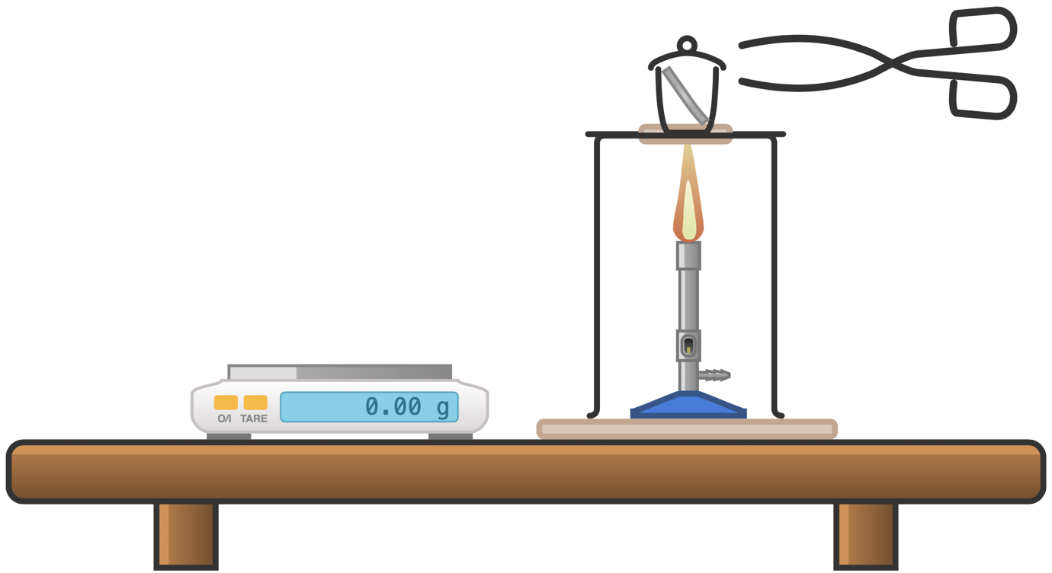
Apparatus:
- Crucible with lid
- Tongs
- Pipe clay triangle
- Bunsen burner
- Tripod
- Heatproof mat
- Tripod
- Access to a 2 d.p. balance

Chemicals:
- Magnesium ribbon (10-15cm)
Method |  | Questions To Ask Students During The Practical
- Twist the magnesium ribbon into a loose coil.  - Weigh the crucible/lid with and without the magnesium inside. Record these two masses.  - Set up the equipment as per the diagram.  - Light the Bunsen burner and heat the crucible, initially with a gentle blue flame, and then a roaring flame to start the reaction.  - After giving the crucible time to heat up, gently lift the lid with the tongs and allow some oxygen to get in. The magnesium should be burning brightly. Replace the lid quickly in order to prevent the magnesium oxide product escaping.  - Continue to heat the crucible, periodically lifting the lid, until the reaction is over. Then heat for a couple of minutes with the lid removed (unless this causes a visible reduction in the product).  - Switch off the Bunsen burner and allow the apparatus to cool.  - Weigh the crucible with lid and product. |  | - Why is it important to tie back long hair and tuck in ties when using spirit burners? (To ensure hair and ties are not accidentally set on fire.)  - Why is it important to stand at our workstations when conducting this experiment? (Sitting does not allow us to quickly move out of the way if something spills or fire spreads on the work surface.)  - Why do allow the crucible to cool before weighing it after heating? (So as to not damage the balance.)  - Why do we use tongs to handle the crucible? (To ensure we do not burn ourselves if the crucible is still hot.)
Calculations |  | Questions To Ask Students During The Calculations
Mass of crucible and lid with magnesium – mass of crucible and lid without magnesium = mass of magnesium  Mass of crucible and lid with magnesium oxide – mass of crucible and lid without magnesium or magnesium oxide = mass of magnesium oxide  Mass of magnesium oxide – mass of magnesium = increase in mass after heating |  | - Why do we give answers only to three significant figures? (This is the fidelity of the measurements we took.)  - Has the mass increased or decreased after heating? (The mass has increased.)  - What explains the change in mass? (The magnesium has burned with the oxygen in the air forming magnesium oxide. The added mass is the mass of the oxygen with which the magnesium has reacted.)
Alternative Methods/Computer Simulations |  | Clearing up
There are many online videos of this experiment being conducted. However, wherever possible students should experience this practical in person.  If your class do not have a great deal of time to carry out this practical, you may wish to assign a different salt to each group and then compare results after the lesson.  If steel crucibles are not available, steel bottle tops can be used. If using steel bottle tops, ensure your technician colleague burns out any plastic before the experiment. |  | It is important that equipment is returned to the prep room in good order. If safe to do so, rinse used equipment and put it in the used equipment tray. If the trays arrived on a trolley, students must return all trays and equipment to that trolley. Anything dirty must be placed into a separate container. Never put dirty equipment back into a tray with clean equipment.  Consult CLEAPSS Hazcards for the salts you are using for up-to-date disposal instructions. Never flush down a drain chemicals that are meant to be disposed of in other ways.  Equipment may be hot after heating. If equipment is too hot to clear away at the end of the lesson, alert your technician colleague to this so they do not injure themselves.
Technician Notes
Ensure the chemicals you provide are free from contamination and the equipment is as clean as possible.

Discuss this practical with the class teacher ahead of time. Ensure they have considered the risks of this practical and are confident with the techniques used. If necessary, provide them with the CLEAPSS hazcards (identified in the risk section section above) so they are comfortable with the chemicals to be used and how to use and dispose of them safely.

Ceramic crucibles can be expensive and weaken on repeated heating. Therefore steel crucibles are recommended.

Always count the magnesium at the start and end of the lesson to ensure none is lost or stolen.

